PATIENT INFORMATION
MVA INTAKE FORM
NAME:__________________________________
DATE: ___________________________________

Today’s Date: ___DD/___MM/____YY/ Date of Accident: ___DD/___MM/____YY/ Date of Birth:___DD/___MM/____YY/
Name: ________________________________________________ Gender:  Male  Female
Address: __________________________________________ City:_________________ Postal Code: ____________
Email: ___________________________________________________ 1st Language: _________________________
Home Phone: ____________________ Mobile Phone: _________________ Work Phone: _____________________
Occupation: ____________________________________________ Are Modified Duties Available? □ Yes □ No
Occupational Status: Full-time Part-time Modified Duties Not Returned Unemployed Retired
Job Requirements:  Mainly sitting Mainly standing  Light labour Heavy Labour
Marital Status: □ Married □ Single □ Divorced □ Common Law Children #: ______ Age(s): _____________
In case of emergency, whom may we contact? Name: ____________ Tel: ______________ Relationship: _________

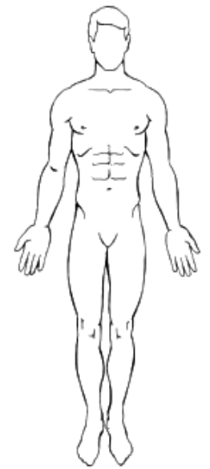
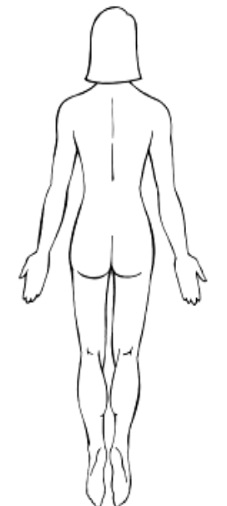
CURRENT SYMPTOMS
On the drawings to the right mark all painful areas using the appropriate symbols:
Numbness: + + + + + Pins and Needles: o o o o o Aching:
Burning: x x x x x Stabbing: / / / / / /

Current complaint(s) and when they started – in order of importance
1)__________________________________________________
2)__________________________________________________
3)__________________________________________________
4) __________________________________________________

Have you had any previous injuries before? □ No □ Yes If yes, when?________________________________________
Have you had any previous work injuries?  No  Yes If yes, when?: ______________________________________
Have you had any previous sporting injuries?  No  Yes If yes, when?: ___________________________________
Have you received any previous therapy? □ No □ Yes If yes, where? _________________________________________
Have you ever been hospitalized? □ No □ Yes If yes, for what and when? _____________________________________
Have you had any previous X-rays, MRI, or other tests? □ No □ Yes If yes, when? ______________________________

MVA INTAKE FORM
NAME:__________________________________
DATE: ___________________________________

HEALTH HISTORY
Are you currently experiencing or do you have a history of the following medical conditions?
General Gastrointestinal Check any of the conditions
 Allergies  Abdominal pain you have or have had:
 Depression  Liver trouble  Alcoholism
 Dizziness  Colitis / Crohn’s  Anemia
 Fainting  Colon trouble  Appendicitis
 Fatigue  Constipation  Arteriosclerosis
 Fever  Diarrhea  Cancer
 Headaches  Difficult Digestion  Diabetes
 Loss of Sleep Diverticulosis  Cholesterol
 Mental Illness  Nausea  Herpes
 Nervousness  Excessive hunger  Cold sores
 Tremors  Gallbladder trouble  Gout
 Weight loss / gain  Hernia  Hepatitis
 Hemorrhoids  Influenza
Muscle / Joint  Vomiting  Pace maker
 Arthritis / rheumatism  Osteoporosis
 Bursitis Genitourinary  Stroke
 Foot trouble  Bladder infection  Tuberculosis
 Muscle Weakness  Kidney problem  Thyroid disorders
 Low back pain  Prostate problem  Epilepsy
 Neck pain  Incontinence
 Mid back pain  Painful urination Central Nervous System Disorders
 Joint pain  If yes, specify: ________________________
Cardiovascular
Skin  High blood pressure Please list any medication you are currently
 Boils  Low blood pressure taking and why:
 Bruise easily  Hardening of arteries
 Dryness  Irregular pulse ___________________________________________
 Hives or allergies  Chest pain
 Itching  Palpitation / Rapid Heartbeat ___________________________________________
 Rash  Poor circulation
 Varicose Veins  Swelling of ankles ___________________________________________
 Eczema  Heart Disease
Have you had any surgeries? When?
Respiratory Women Only
 Shortness of breath  Hot flashes ____________________________________________
 Chronic cough  Lumps in breast
 Difficulty breathing  Menopause ____________________________________________
 Hay fever  Vaginal discharge
 Wheezing Menstrual Flow ____________________________________________
 Asthma  Reg.  Irreg.  Pain/Cramps
 Bronchitis Are you Pregnant  yes  no
Are you currently, or ever been a smoker?  yes  no
Family Doctor: _______________________________ Tel: ________________________________
Can we contact your family doctor to discuss relevant information regarding your treatment plan? □ Yes □ No

ACCIDENT HISTORY
MVA INTAKE FORM
NAME:__________________________________
DATE: ___________________________________

Description and Location of the accident: __________________________________________________________________________________________
__________________________________________________________________________________________
__________________________________________________________________________________________
Condition of the road:  Dry  Wet/Rainy  Snow Anticipation of Accident?  No  Yes
Time of the day:  AM____:____  PM _____:_____
Patient’s vehicle: _____________________________ Speed: ____________________km/hr
Other vehicle: _______________________________ Speed: ____________________km/hr
Collision type:
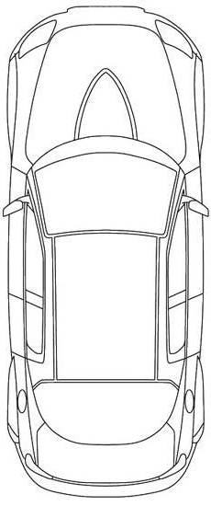
 Front-End  Side-End  Side-Swipe  Rear-End
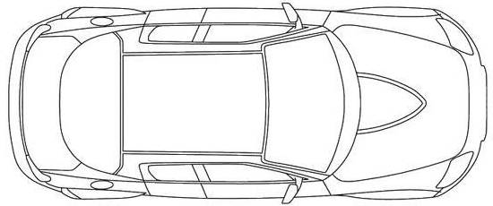
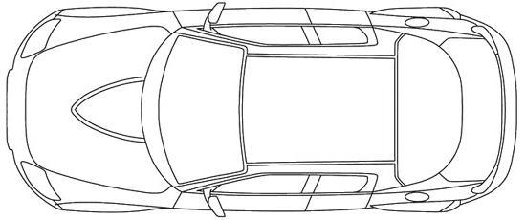

Was the vehicle towed?  No  Yes Impact with other Objects:  No  Yes: ___________________
Exit from vehicle:  Self-powered  Required Assistance Loss of consciousness:  No  Yes:
Safety equipment (seatbelt):  Off  On Air-bag deployed:  No  Yes
Were you the driver?  No  Yes Passengers?  Front  Back Left  Back Right
Dominant Hand:  Left  Right
Did any part of your body collide with any objects? (circle all that apply) HEAD SHOULDER ARM HAND
CHEST HIP LEG KNEE

Symptoms following accident:
Headache  Immediate  Later Head/Neck  Immediate  Later
Dizziness  Immediate  Later Back  Immediate  Later
Chest pain  Immediate  Later Shoulders  Immediate  Later  Left  Right
Nausea /vomit  Immediate  Later Legs  Immediate  Later  Left  Right
Bleeding  :_________________ Arms  Immediate  Later  Left  Right
Other: ______________________________________
Emergency Personnel on Scene (check all that apply)  Police Fire Truck  Ambulance
Hospitalized? No  Yes: __________________________ Transportation: By ambulance Own transportation
Date: ________ Examinations:  X-rays  CT-Scan  MRI Other: __________________________________
Treatment:_______________________________________________________________________________________
Have you seen a doctor since the accident?  No  Yes Who:_______________________ Date: ________________
Treatment/Recommendations: _______________________________________________________________________

Attendance Sheet
Name:______________________________________

1. Treatment Plan:___________________________ Approved:_____________________
2. Treatment Plan:___________________________ Approved:_____________________
3. Treatment Plan:___________________________ Approved:_____________________
4. Treatment Plan:___________________________ Approved:_____________________
5. Treatment Plan:___________________________ Approved:_____________________
6. Treatment Plan:___________________________ Approved:_____________________
7. Treatment Plan:___________________________ Approved:_____________________
# | Date | Signature | # | Date | Signature
1 |  |  | 35
2 |  |  | 36
3 |  |  | 37
4 |  |  | 38
5 |  |  | 39
6 |  |  | 40
7 |  |  | 41
8 |  |  | 42
9 |  |  | 43
10 |  |  | 44
11 |  |  | 45
12 |  |  | 46
13 |  |  | 47
14 |  |  | 48
15 |  |  | 49
16 |  |  | 50
17 |  |  | 51
18 |  |  | 52
19 |  |  | 53
20 |  |  | 54
21 |  |  | 55
22 |  |  | 56
23 |  |  | 57
24 |  |  | 58
25 |  |  | 59
26 |  |  | 60
27 |  |  | 61
28 |  |  | 62
29 |  |  | 63
30 |  |  | 64
31 |  |  | 65
32 |  |  | 66
33 |  |  | 67
34 |  |  | 68

NAME:__________________________________
DATE: __________________________________
TX Plan #_________________Page ________
Date: | Visit#: |  |  |  | Clinician:
Subjective: □ Improving □ No Change □ Worsening |  |  | Assessment |  | SMT:  STT:
Objective: |  |  |  |  | SMT:  STT:
Exercises (See POM for details)  - Cardio:  - Stretch:  - Strength: |  | PT  - IFC:  - U/S:  - Heat:  - Ice: |  | Other: | Education:

Date: | Visit#: |  |  |  | Clinician:
Subjective: □ Improving □ No Change □ Worsening |  |  | Assessment |  | SMT:  STT:
Objective: |  |  |  |  | SMT:  STT:
Exercises  - Cardio:  - Stretch:  - Strength: |  | PT  - IFC:  - U/S:  - Heat:  - Ice: |  | Other: | Education:

Date: | Visit#: |  |  |  | Clinician:
Subjective: □ Improving □ No Change □ Worsening |  |  | Assessment |  | SMT:  STT:
Objective: |  |  |  |  | SMT:  STT:
Exercises  - Cardio:  - Stretch:  - Strength: |  | PT  - IFC:  - U/S:  - Heat:  - Ice: |  | Other: | Education:

Date: | Visit#: |  |  |  | Clinician:
Subjective: □ Improving □ No Change □ Worsening |  |  | Assessment |  | SMT:  STT:
Objective: |  |  |  |  | SMT:  STT:
Exercises  - Cardio:  - Stretch:  - Strength: |  | PT  - IFC:  - U/S:  - Heat:  - Ice: |  | Other: | Education:

CERVICAL
 | L | R
Neutral | + - | + -
Jackson’s | + - | + -
Spurling’s | + - | + -
L’Hermitte | + - | + -
Jull’s | + - ______s
Adson’s | + - | + -
Wrights | + - | + -
Edens | + - | + -
Easts | + - | + -
Doorbell | + - | + -
LUMBAR
 | Left | Right
SLR
Braggarts | + - | + -
Bowstring | + - | + -
Thomas | + - | + -
Fig4 | + - | + -
SI comp | + - | + -
Yeomans | + - | + -
Hibbs | + - | + -
Gillet’s | + - | + -
Sorenson’s | + - _________s

Gait: Antalgic Normal
Assistive Devices: _________________
MVA INTAKE FORM
NAME:___________________________________
DATE: ___________________________________

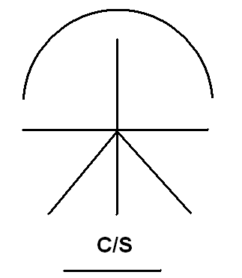
SHOULDER
ROM |  | L (%) |  | R (%)
Flexion (180°)
Extension (50°)
Abduction (180°)
Internal Rotation (90°)
External Rotation (80°)
Horizontal abd (30°)
Horizontal add (130°)
Scapulocostal rhythm
Ortho
Speed’s | + - |  | + -
Yergason’s | + - |  | + -
Empty Can | + - |  | + -
Hornblowers | + - |  | + -
Hawkins-Kennedy | + - |  | + -
Neer’s | + - |  | + -
O’brien’s | + - |  | + -
Crank | + - |  | + -
Load & Shift | + - |  | + -
Anterior Apprehension | + - |  | + -

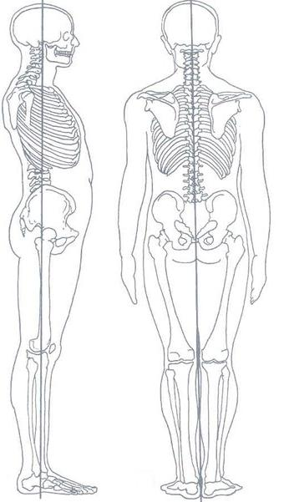

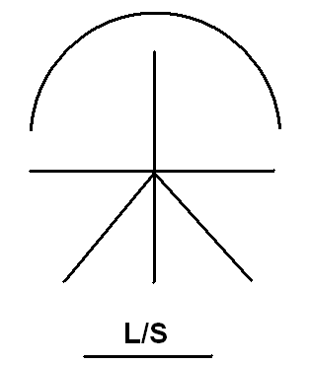

Neurological
DTR |  |  | Motor
 | L | R |  | L | R
C5 |  |  | C5
C6 |  |  | C6
C7 |  |  | C7
L4 |  |  | C8
S1 |  |  | T1
Sensory |  |  | L4
 |  |  | L5
 |  |  | S1

KNEE
ROM | L (%) | R (%)
Flexion (150°)
Extension(0°)
Internal Rot
External Rot
Ortho
Varus | + - | + -
Valgus | + - | + -
Anterior Drawer | + - | + -
Posterior Drawer | + - | + -
Joint Line Tenderness | + - | + -
Thesseli’s | + - | + -
McMurray’s | + - | + -
Patello-Femoral Grind | + - | + -
Ober’s | + - | + -
Noble’s Comp | + - | + -
Patellar Comp | + - | + -

ELBOW
ROM | L (%) | R (%)
Flexion (150°)
Extension (0°)
Supination (90°)
Pronation(90°)
Ortho
Cozen’s | + - | + -
Reverse Cozen’s | + - | + -
Tinel’s (elbow) | + - | + -
Tinel’s (Wrist) | + - | + -
Varus stress | + - | + -
Valgus Stress | + - | + -

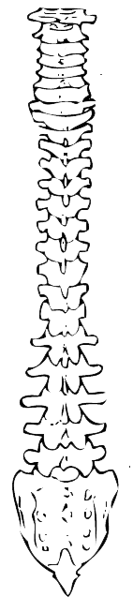

Diagnosis:

Plan of Management: ___ times per Week for ____ Weeks Refer/Request: X-rays US MRI CT-Scan Massage Therapy SMT  Mobs IFC/TENS US Stretches/Strengthening Acupuncture Decomp Goals: ↑ROM ↑Strength ↓Swelling ↓Hypertonicities ↓Pain

Clinician: _____________ Date:___________

SUBJECTIVE EVALUATION
MVA INTAKE FORM
NAME:___________________________________
DATE: ___________________________________

SPINE
Headache:  Present Pain: □ intermittent □ constant □ improving □ worsening □ unchanged  Type of pain: □ steady/dull/achy □ steady/sharp □ pounding  Intensity: VAS ______/10  Duration: _________(s/min/hr)  Numbness? □ Yes □ No  Paraesthesia? □ Yes □ No  Aggravated by:  □ movements________________ □ lie down  □ cough/sneeze □ lights/noise  Relieved by:__________________________________________________ | Cervical Spine:  Present Pain: □ intermittent □ constant □ improving □ worsening □ unchanged  Type of pain:  □ achy □ sharp □ dull □ stiff □ burning  Intensity: VAS _______/10  Duration: _________(s/min/hr)  Radiation? □ Yes □ No Numbness? □ Yes □ No  Paraesthesia? □ Yes □ No  Where?__________________________________________  Aggravated by:  □ movements______________ □ prolonged positions  □ End ROM □cough/sneeze □deep breath □ WNL  Relieved by:_____________________________________
Thoracic Spine:  Present Pain: □ intermittent □ constant □ improving □ worsening □ unchanged  Type of pain:  □ achy □ sharp □ dull □ stiff □ burning  Intensity: VAS _______/10  Duration: _________(s/min/hr)  Radiation? □ Yes □ No Numbness? □ Yes □ No  Paraesthesia? □ Yes □ No  Where?__________________________________________  Aggravated by:  □ movements______________ □ prolonged positions  □ End ROM □cough/sneeze □deep breath □ WNL  Relieved by:__________________________________________________ | Lumbar Spine:  Present Pain: □ intermittent □ constant □ improving □ worsening □ unchanged  Type of pain:  □ achy □ sharp □ dull □ stiff □ burning  Intensity: VAS _______/10  Duration: _________(s/min/hr)  Radiation? □ Yes □ No Numbness? □ Yes □ No  Paraesthesia? □ Yes □ No  Where?__________________________________________  Aggravated by:  □ movements______________ □ prolonged positions  □ End ROM □cough/sneeze □deep breath □ WNL  Relieved by:__________________________________________________

PERIPHERAL JOINT
Joint:________________________  Present Pain:  - intermittent  - constant  - improving  - worsening  - unchanged  Type of pain:  □ achy □ sharp □ dull □ stiff  □ burning  Intensity: VAS _______/10  Duration: _________(s/min/hr)  Radiation? □ Yes □ No  Numbness? □ Yes □ No  Paraesthesia? □ Yes □ No  Where?______________________  Aggravated by:  - movements________________  - prolonged positions  Relieved by:__________________  ____________________________ | Joint:________________________  Present Pain:  - intermittent  - constant  - improving  - worsening  - unchanged  Type of pain:  □ achy □ sharp □ dull □ stiff  □ burning  Intensity: VAS _______/10  Duration: _________(s/min/hr)  Radiation? □ Yes □ No  Numbness? □ Yes □ No  Paraesthesia? □ Yes □ No  Where?______________________  Aggravated by:  - movements________________  - prolonged positions  Relieved by:__________________  ____________________________ | Joint:________________________  Present Pain:  - intermittent  - constant  - improving  - worsening  - unchanged  Type of pain:  □ achy □ sharp □ dull □ stiff  □ burning  Intensity: VAS _______/10  Duration: _________(s/min/hr)  Radiation? □ Yes □ No  Numbness? □ Yes □ No  Paraesthesia? □ Yes □ No  Where?______________________  Aggravated by:  - movements________________  - prolonged positions  Relieved by:__________________  ____________________________ | Joint:________________________  Present Pain:  - intermittent  - constant  - improving  - worsening  - unchanged  Type of pain:  □ achy □ sharp □ dull □ stiff  □ burning  Intensity: VAS _______/10  Duration: _________(s/min/hr)  Radiation? □ Yes □ No  Numbness? □ Yes □ No  Paraesthesia? □ Yes □ No  Where?______________________  Aggravated by:  - movements________________  - prolonged positions  Relieved by:__________________  ____________________________

- Post traumatic HA
- Dizziness
- Nausea
- Vomiting
- Ringing ears

- Balance problem
- Jaw pain
- Breathing problem
- Sleep Problems
- Fear of Driving

- Mood Swing
- Concentration problem
- Frustration/Anger
- Sadness

- Fever
- Shock
- Crying

TMJ SCREENING

Name: _________________________________________ DOI: ____DD/_____MM/_____YY/

This questionnaire was designed to provide important facts regarding the history of your condition. To assist in determining the source of any problem, please take your time and answer each question as completely and honestly as possible. Please sign each page.
Note: Please ensure that symptoms identified in the following questionnaire were not present before the MVA or have been greatly exacerbated after the MVA.

Do you have any PAIN in the following areas:
Speaking Facial pain Clenching at night
Grinding of teeth (Bruxism) Waking up with jaw pain Neck pain
Opening Wide Ear Pain Jaw Clicking or Popping
Muscle soreness (face) Throat Pain Jaw (Cheeks)
Jaw-Joint Temples Teeth pain
Eating Chewing food Sleeping

Have you noticed any Occurrence of the following symptoms:
Headaches Ringing in the Ears Ear Congestion
Clogged/Itchy Ears Hair/Scalp pain to touch Sinus Congestion
Eyes sensitive to light Blurry vision or spots Frequent clearing of throat
Pain behind eyes. Poor Sleep Patterns Difficulty swallowing
Muscle twitching Dizziness Visual Disturbance
Rigid or tight Jaw Clenching teeth day/night Balance disturbance
Locking of Jaw Chewing on only one side of mouth

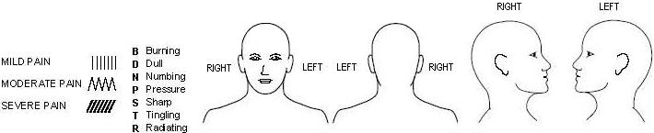
Draw Your Pain Patterns
Following This Key:

Rate (Circle)Your Pain Intensity (0 is NO PAIN and 10 is MOST SEVERE PAIN)
0-----1-----2-----3-----4-----5-----6-----7-----8-----9-----10

Patient Signature: __________________________ Date:_______________
- A. Injury Characteristics Date of Injury: ___{DD}/____{MM}/____{YY}/ Time of Injury ___:___am/pm Reporter: Patient Parent Spouse Other
- Injury Description: ___________________________________________________________________________
__________________________________________________________________________________________
1a. Is there evidence of a forcible blow to the head (direct or indirect)? Yes No Unknown
1b. is there evidence of intracranial injury or skull fracture? Yes No Unknown
1c. Location of Impact: Frontal Lft Temp Rt Temp Lft Parietal Rt Parietal Occipital Neck Indirect Force
2. Cause: MVC Pedestrian-MVC Fall Assault Sports(specify)__________________ Other:_______________
3. Amnesia Before (Retrograde) Are there any events just BEFORE the injury that you/ person has no memory of (even brief)? Yes No Duration:
4. Amnesia After (Anterograde) Are there any events just AFTER the injury that you/ person has no memory of (even brief)? Yes No Duration:
5. Loss of Consciousness: Did you/ person lose consciousness? Yes No Duration:
6. EARLY SIGNS: Appears dazed or stunned Is confused about events Answers questions slowly Repeats Questions Forgetful (recent info)
7 Seizures: Were seizures observed? Yes No Detail:_____________________________________________________________________________________
ACUTE CONCUSSION EVALUATION
Name: ____________________________
DOB: ___DD/___MM/____YY/

B. Symptom Check List: Since the injury, has the person experienced any of these symptoms any more than usual today or in the past day?
Indicate presence of each symptom (0=No, 1-Yes)

PHYSICAL (10) |  | COGNITIVE (4) |  | SLEEP (4)
Headache | 0 1 | Feeling mentally foggy | 0 1 | Drowsiness | 0 1
Nausea | 0 1 | Feeling slowed down | 0 1 | Sleeping less than usual | 0 1 N/A
Vomiting | 0 1 | Difficulty concentrating | 0 1 | Sleeping more than usual | 0 1 N/A
Balance Problems | 0 1 | Difficulty remembering | 0 1 | Trouble falling asleep | 0 1 N/A
Dizziness | 0 1 | COGNITIVE Total (0-4) ___ |  | SLEEP Total (0-4) ____
Visual Problems | 0 1 | EMOTIONAL (4) |  | Exertion: Do these symptoms worsen with:  Physical Activity Yes No N/A  Cognitive Activity Yes No N/A  Overall Rating: How different is the person acting compared to his/her usual self? (circle)  Normal 0 1 2 3 4 5 6 Very Different
Fatigue | 0 1 | Irritability | 0 1
Sensitivity to light | 0 1 | Sadness | 0 1
Sensitivity to noise | 0 1 | More emotional | 0 1
Numbness/Tingling | 0 1 | Nervousness | 0 1
PHYSICAL Total (0-10)___ |  | EMOTIONAL Total (0-4) ____
(Add Physical, Cognitive, Emotion, Sleep Totals)  Total Symptom Score (0-22) |  |  | _____

C. Risk Factors for Protracted Recovery: (Check all that apply)
Concussion History? Yes No | √ | Headache History Yes No | √ | Developmental History | √ | Psychiatric History | √
Previous # 1 2 3 4 5 6+ |  | Prior treatment for headache |  | Learning Disabilities |  | Anxiety
Longest symptom duration  Days Weeks Months Years |  | History of migraine headache  Personal  Family ____________________  ____________________________ |  | Attention-Deficit/ Hyperactivity Disorder |  | Depression
 |  |  |  |  |  | Sleep Disorder
If multiple concussions, less force caused reinjury? Yes No |  |  |  | Other Developmental Disorder_____________ |  | Other psychiatric disorder  ______________________
List other comorbid medical disorders or medication usage (e.g,. hypothyroid, seizures) ________________________________
___________________________________________________________________________________________

D. RED FLAGS for acute emergency management: Refer to the emergency department with sudden onset of any of the following:
- Headaches that worsen - Looks very drowsy/ can’t be awakened - Can’t recognize people or places - Neck pain
- Seizures - Repeated Vomiting - Increasing confusion or irritability - Unusual behavioral change
- Focal neurologic signs - Slurred speech - Weakness or numbness in arms/legs - Change in state of consciousness
E. Diagnosis: Concussion w/o LOC Concussion w/ LOC Concussion (Unspecified) No Diagnosis Other _______________
F. Follow-Up Action Plan No Follow-Up Needed Clinician Monitoring
Referral: Neuropsychological Testing Emergency Department
Physician: Neurosurgery Neurology Sports Medicine Physiatrist Other _________

ACE Completed by: _____________________________ Date: __________________

Report of Findings

Patient’s Name: Date of Assessment:
Presenting Complaint

Examination Findings

Diagnosis

Plan of Management (Passive (STT, SMT, modality) Active Care (stretch/strength) Frequency/Duration, Further Imaging)
Physiotherapy

Goals (Benefits, Outcome Measures, Disability)

Risks Discussed:

Alternatives:

Prognosis (Positive Factors, negative Factors, Short-term/Long-term, Expected Recovery)

Estimated time for recovery:
Patient Questions

Date | Patient Signature | Clinician Signature

The Patient-Specific Functional Scale

This useful questionnaire can be used to quantify activity limitation and measure functional outcome for patients with any orthopaedic condition.

Clinician to read and fill in below: Complete at the end of the history and prior to physical examination.

Initial Assessment:
I am going to ask you to identify up to three important activities that you are unable to do or are having difficulty with as a result of your _________________ problem. Today, are there any activities that you are unable to do or having difficulty with because of your _________________ problem? (Clinician: show scale to patient and have the patient rate each activity).

Follow-up Assessments:
When I assessed you on (state previous assessment date), you told me that you had difficulty with (read all activities from list at a time). Today, do you still have difficulty with: (read and have patient score each item in the list)?

Patient-specific activity scoring scheme (Point to one number):

0 1 2 3 4 5 6 7 8 9 10
Unable Able to perform
to perform activity at same
activity level as before
injury or problem

(Date and Score)

Activity Initial

Activity | Initial
1.
2.
3.
4.
5.
Additional
Additional

Total score = sum of the activity scores/number of activities
Minimum detectable change (90%CI) for average score = 2 points
Minimum detectable change (90%CI) for single activity score = 3 points

PSFS developed by: Stratford, P., Gill, C., Westaway, M., & Binkley, J. (1995). Assessing disability and change on individual patients: a report of a patient specific measure. Physiotherapy Canada, 47, 258-263.

Reproduced with the permission of the authors.

Informed Consent to Chiropractic Treatment

There are risks and possible risks associated with manual therapy techniques used by doctors of chiropractic. In particular you should note:

- While rare, some patients may experience short term aggravation of symptoms or muscle and ligament strains or sprains as a result of manual therapy techniques. Although uncommon, rib fractures have also been known to occur following certain manual therapy procedures;
- There are reported cases of stroke associated with visits to medical doctors and chiropractors. Research and scientific evidence does not establish a cause and effect relationship between chiropractic treatment and the occurrence of stroke rather, recent studies indicate that patients may be consulting medical doctors and chiropractors when they are in the early stages of a stroke. In essence, there is a stroke already in progress. However, you are being informed of this reported association because a stroke may cause serious neurological impairment or even death. The possibility of such injuries occurring in association with upper cervical adjustment is extremely remote;
- There are rare reported cases of disc injuries identified following cervical and lumbar spinal adjustment, although no scientific evidence has demonstrated such injuries are caused, or may be caused, by spinal adjustments or other chiropractic treatment;
- There are infrequent reported cases of burns or skin irritation in association with the use of some types of electrical therapy offered by some doctors of chiropractic.

I acknowledge I have read this consent and I have discussed, or have been offered the opportunity to discuss, with my chiropractor the nature and purpose of chiropractic treatment in general, (including spinal adjustment), the treatment options and recommendations for my condition, and the contents of this Consent.

I consent to the chiropractic treatment recommended to me by my chiropractor including any recommended spinal adjustments.

I intend this consent to apply to all my present and future chiropractic care.

________________________ __________________
Signature Date

________________________
Name (please print)

Informed Consent to Physiotherapy Treatment

I give my permission to undergo physical examination by a physiotherapist, and treated thereafter by either the physiotherapist himself or by a Physiotherapy Assistant or Kinesiologist.

I understand that I would be assessed and treated by a registered physiotherapist. Assessment will consist of history taking or interview, provocative tests, exposure and palpation of body part(s) that are essential for thorough examination. Treatment may consist of therapeutic, heating and cold modalities, manual therapy and exercises.

I am aware that occasionally, some mild to moderate form of physical discomfort may arise from physical assessment and initial utilization of certain treatment. I understand that depending on patients health status, chronicity of musculoskeletal problem, age, activity level, etc, reaction to and efficacy of treatment may vary.

Thus, I understand that I have to inform my physiotherapist immediately of any concerns or discomfort regarding my physical examination and treatment.

Consent for Personal Information

I understand that to provide me with physiotherapy services and products, this clinic will collect some information about me (e.g home telephone number, address, health number, medication used, email address to send some home instructions, and other pertinent information that may be essential to my physical recovery).

I understand how the Privacy Policy of this Clinic applied to me. I have been given the chance to ask any questions I have about the Privacy Policy and they were answered to my satisfaction. I understand how the collection, use and disclosure of personal information are utilized, steps taken to protect the information, and my right to review this information.

I also give the permission to the release of my physiotherapy information to my family physician specialist of if WSIB-related treatment, to my employer. I agree to this clinic in collecting, using and disclosing personal information about me as set out above and in this clinic’s Privacy Policy.

I understand that, as explained in the Privacy Policy, there are some rare exceptions to these commitments.

________________________ __________________
Signature Date

________________________
Name (please print)

Informed Consent to Massage Treatment

I, the undersigned give my full and voluntary consent to a treatment by a qualified massage therapist to assess and treat me in accordance with my needs.

I acknowledge that I understand the nature of the treatment, the expected benefits of the treatment, and the material risks and side effects of the treatment proposed and any of the alternative options.

I further comprehend the likely consequences of not having the treatment.

I remain free to withdraw my consent in writing at any time and the treatment shall cease at such time as well.

________________________ __________________
Signature Date

________________________
Name (please print)

MEDICAL AUTHORIZATION

TO:

RE:

I, the undersigned, do hereby authorize and direct you to release to my treating rehabilitation facility Bloor West Rehabilitation Centre, 3250 Bloor street West, Suite 126, Etobicoke, Ontario M8X 2X9 with my files and all relevant and permanent information, documents, reports, clinical notes and records, imaging findings, physiotherapy records and all papers relevant to the above reference(s) and let this be your goods for so doing.

Dated at _____________ this ________ day of _________________ 20____

________________________________ _______________________________
Patient Witness

3250 Bloor St. W., Suite 126
Toronto, ON, M8X 2X9
Tel: 416-236-7778 Fax: 416-236-9777

PATIENT AUTHORIZATION FORM FOR EXCHANGE OF MEDICAL INFORMATION
TO:
Physician: Dr.
Address:
Phone:
Fax:
RE:
Patient Name:
DOB:

____ I understand that I may refuse to sign this form, and that my rehabilitation care will not be affected if I do not sign this form

I, ___________________ hereby direct and authorize you to exchange my medical file and health information with Health Bound Health Network to the attention of:

Dr. Eric H. Ho, DC, Clinician.

Comments: For the purposes of determining appropriate treatment plan,
Please forward any imaging reports including x-ray, ultrasound, MRI, CT scan from _____________________________. Thank you.

- Please include any specialist consultation/operative notes.

______________________________________________ ___________________
Signature of patient or patient’s Representative/Guardian Date
(Form MUST be completed before signing)

If a patient’s representative signs this authorization, please complete the following:

Print name of representative
Relationship to patient

AUTHORIZATION AND DIRECTION

TO: ____________________________________________________________________________________________
FROM: _________________________________________________________________________________________
RE: Patient’s Name: __________________________________________________________________________
Automobile Insurer: _______________________________________________________________________
Claim/Policy Number: _____________________________________________________________________
Date of Loss: ____________________________________________________________________________
Social Insurance Number: __________________________________________________________________
Legal Representative: ______________________________________________________________________
Primary Insurer: __________________________________________________________________________

I, ____________________________________________, AUTHORIZE AND DIRECT you as follows:

- Full and Final Settlement:

In the event of Full and Final Settlement, I authorize and direct you to remit payment directly to Bloor West Rehabilitation Centre, in satisfaction of its accounts first, prior to remitting payment for the reminder of settlement funds to either myself or my legal representative.

- Release of Information:

I authorize Bloor West Rehabilitation Centre to furnish to my Insurance Company, Physician, Case Worker, Adjuster, Employer or Lawyer all information in your possession directly relating to my medical condition and treatment received at the above clinic.

- Direct Billing:

I authorize and direct you to accept direct billing from Bloor West Rehabilitation Centre, for any and all documentation pertaining to benefits paid.

- Negotiation and Meditation:

I authorize Bloor West Rehabilitation Centre and its agents to negotiate, mediate and litigate on my behalf and to receive payment for treatment and services provided by Bloor West Rehabilitation Centre.

- Denied and Incurred Treatment
In the event of Denied and Incurred Treatment, I authorize and direct you to remit payment directly to Bloor West Rehabilitation Centre, in satisfaction of its outstanding accounts for any services rendered.

All prior Direction and Authorizations, Instructions and Powers of Attorneys are hereby revoked.

This shall be your full, complete, sufficient and irrevocable authorization for so doing.

DATED AT ___________________ in the Province of Ontario, this __________ day of ___________________, 20____

Patient’s Signature: ___________________________________

Witness’ Name: ______________________________________

Witness’ Signature: ___________________________________

To Whom It May Concern:

I am aware that as per Section 47 (2) of the Statutory Accident Benefits Schedule (SABS), I must exhaust my personal collateral coverage prior to my automobile insurance reimbursing my treating facility for services rendered.

I am aware that any funds I do receive from the above-mentioned extended health carrier are to promptly be paid to Bloor West Rehabilitation Centre. I am also aware that a copy of the Explanation of Benefits is to be provided also so that it may be forwarded to my automobile insurance adjuster so not to delay any payment to Bloor West Rehabilitation Centre.
In the event that I fail to provide Bloor West Rehabilitation Centre with payment or the explanation of benefits, I am aware that the amount may be deducted from my settlement portion upon my file closing or that Bloor West Rehabilitation Centre reserves the right to seek further action.

DATED AT _______________ in the Province of Ontario, this ______ day of __________, 20____.

Patient’s Name: _______________________________
Patient’s Signature: ___________________________
Witness’ Name: _______________________________
Witness’ Signature: ____________________________

To Whom It May Concern:

Subject to the Statutory Accidents Benefits Schedule, in those circumstances where prior approval is required, I understand that if I undertake any of the proposed services prior to approval by the insurer, I will be responsible for payment to my provider for any of the services rendered on my behalf and will be paid by my legal representative out of my settlement once my Accident Benefit file has been settled and closed.

DATED AT _______________ in the Province of Ontario, this ______ day of __________, 20____.

Patient’s Name: __________________________
Patient’s Signature: ______________________
Witness’ Name: __________________________
Witness’ Signature: _______________________

